The Union Blockade and Anaconda Plan:
Analyze “Scott’s Great Snake”
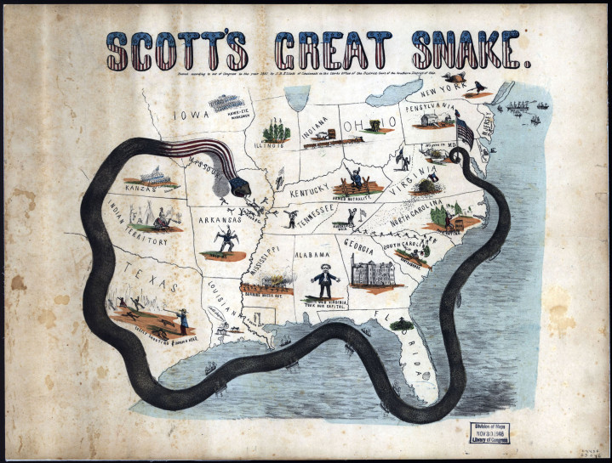
Directions: Carefully review “Scott’s Great Snake.” On your own paper, write a detailed list, in complete sentences, that describes what you see in this image. Be specific and use detail! Why do you think these details were included in the political cartoon?
Consider the following questions as you write your list of details:
- Who is Scott?

- What does the snake represent?

- Why was this map created?
- Make inferences about the mapmaker’s point-of-view and bias based on these observations.

- What evidence do you observe that supports your interpretation?

- What might be different if someone else with an alternate point-of-view made this map?

