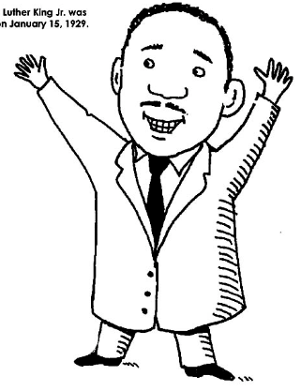
“Brain” – Ideas and philosophies
What did s/he think about people or about the world?
____________________________________________________________________
____________________________________________________________________
____________________________________________________________________
________________________________________________________________

“Mouth” – A famous quote by or about your person
What did s/he say?
____________________________________________________________________
_____________________________________________________________________
_____________________________________________________________________
_____________________________________________________________________

“Right Hand” – Actions
What did s/he do or accomplish?
_________________________________________________________________________
_________________________________________________________________________
_________________________________________________________________________
_________________________________________________________________________

“Achilles Heel” – Weaknesses, setbacks, mistakes, and hardships
What did s/he overcome or deal with? What mistakes were made?
_______________________________________________________________________________
_______________________________________________________________________________
_______________________________________________________________________________
_______________________________________________________________________________

“Foundation” – Background, influences, origins, and family
Where did s/he grow up? Who/what taught or influenced him/her?
What was his/her family like? Did something major happen in his/her
lifetime?
________________________________________________________________________________
________________________________________________________________________________
________________________________________________________________________________
_______________________________________________________________________________

“Eyes” – Visions, goals, and hopes
What kind of future did s/he want for him/herself or others?
______________________________________________________________________
______________________________________________________________________
______________________________________________________________________
______________________________________________________________________

“Shoulder” – Strengths and positive attributes
What is s/he good at?
__________________________________________________________
__________________________________________________________
__________________________________________________________
__________________________________________________________

“Left Hand” – Contributions to history
Why is this person remembered?
________________________________________________________________
________________________________________________________________
________________________________________________________________
________________________________________________________________

“Heart” – Objects or people this person value(s)
Who/what did your person love or value?
______________________________________________________________________
______________________________________________________________________
______________________________________________________________________
______________________________________________________________________

“The Road” – List 5 important events from this person’s life
Event ↓ Date ↓
- _________________

- _________________

- _________________

- _________________

- _________________
“Brain” – Ideas and philosophies
What did s/he think about people or about the world?
____________________________________________________________________
____________________________________________________________________
____________________________________________________________________
________________________________________________________________

“Mouth” – A famous quote by or about your person
What did s/he say?
____________________________________________________________________
_____________________________________________________________________
_____________________________________________________________________
_____________________________________________________________________

“Right Hand” – Actions
What did s/he do or accomplish?
_________________________________________________________________________
_________________________________________________________________________
_________________________________________________________________________
_________________________________________________________________________

“Achilles Heel” – Weaknesses, setbacks, mistakes, and hardships
What did s/he overcome or deal with? What mistakes were made?
_______________________________________________________________________________
_______________________________________________________________________________
_______________________________________________________________________________
_______________________________________________________________________________

“Foundation” – Background, influences, origins, and family
Where did s/he grow up? Who/what taught or influenced him/her?
What was his/her family like? Did something major happen in his/her
lifetime?
________________________________________________________________________________
________________________________________________________________________________
________________________________________________________________________________
_______________________________________________________________________________

“Eyes” – Visions, goals, and hopes
What kind of future did s/he want for him/herself or others?
______________________________________________________________________
______________________________________________________________________
______________________________________________________________________
______________________________________________________________________

“Shoulder” – Strengths and positive attributes
What is s/he good at?
__________________________________________________________
__________________________________________________________
__________________________________________________________
__________________________________________________________

“Left Hand” – Contributions to history
Why is this person remembered?
________________________________________________________________
________________________________________________________________
________________________________________________________________
________________________________________________________________

“Heart” – Objects or people this person value(s)
Who/what did your person love or value?
______________________________________________________________________
______________________________________________________________________
______________________________________________________________________
______________________________________________________________________

“The Road” – List 5 important events from this person’s life
Event ↓ Date ↓
- _________________

- _________________

- _________________

- _________________

- _________________

