Foundations, Legislative Branch, and How a Bill Becomes a Law

Directions: Answer the following questions to the best of your ability.

- In what way is the Georgia Constitution similar to the United States Constitution?
  - They each have been amended 27 times.
  - They each contain just seven “articles.”
  - They each have remained unchanged since their approval.
  - They set up a separation of powers within the government.

Use the following chart to answer the question below.
?
Veto Override
Reject presidential nominations for federal judges
Impeach and remove President

- Which is the best title for this chart?
  - Judicial Branch Checks over the Executive Branch
  - Judicial Branch Checks over the Legislative Branch
  - Legislative Branch Checks over the Judicial Branch
  - Legislative Branch Checks over the Executive Branch

- The structure of the government of Georgia allows for the Legislative Branch to write laws, the Executive Branch to enforce laws, and the Judicial Branch to interpret laws. Collectively, this type of structure is called
  - Federalism.
  - Republicanism.
  - checks and balances.
  - separation of powers.

Use the following chart to answer the question below.
Citizens’ Rights | Citizens’ Responsibilities
Freedom of Assembly | Voting
Freedom of Speech | Obeying laws
Freedom of Religion | ?

- Which of these best completes the chart?
  - Protection for the accused
  - Bearing and keeping arms
  - Freedom of the press
  - Serving on juries

- Why is paying taxes considered a civic responsibility of citizens living in a democracy?
  - Taxes allow private businesses to grow.
  - Congress has the power to tax laws.
  - Non-payment of taxes results in imprisonment.
  - Taxes support government services and programs.

- Which is an example of a right of American citizens?
  - Serving on a jury
  - Freedom of the press
  - Participating in surveys
  - Following the country’s laws

- When citizens cast votes for President in November, they are participating in a

- primary election.
- general election.
- midterm election.
- special election.

- In order for a person to be able to vote in the state of Georgia, he or she must
  - have a driver’s license.
  - be a property owner.
  - be a legal resident of the state of Georgia.
  - have lived in the country for at least four years.

Use the following chart answer the question below.
Exceptions to the Right to Vote in the State of Georgia
A person who has been judicially determined to be mentally incompetent
?

- Which best completes the chart?
  - A person born outside of Georgia, but who is a current resident.
  - A person convicted of a felony who is currently serving a sentence.
  - A person born outside the United States who is a naturalized citizen.
  - A person dishonorably discharged from any branch of the U.S. military.

- The main function of political parties in the United States is to
  - narrow down choices for citizens voting in elections.
  - ensure that the country remains a representative democracy.
  - keep certain types of political candidates out of power.
  - help people with similar political ideas express their view.

- The most important duty of the members of the General Assembly is to
  - remove judges.
  - impeach governors.
  - make and amend laws.
  - regulate and license insurers.

Use the following chart to answer the question below.
Qualifications of Members of the Georgia Senate
Must be a citizen of the United States
Must be at least 25 years old
?

- Which of these best completes the chart?
  - Must be married by the time he or she takes office
  - Must have been a legal resident of Georgia for two years
  - Must be part of the same political party as the governor
  - Must own at least one piece of land in the state of Georgia

- The Georgia General Assembly is comprised of the
  - the Senate and the Cabinet.
  - the Senate and the House of Representatives.
  - the Cabinet and the House of Representatives.
  - the House of Representatives and the Speaker.

- The members of the Georgia House of Representatives are elected by voters of Georgia and serve for
  - 1 year.
  - 2 years.
  - 4 years.
  - 6 years.

- Which position serves as the leader of the Senate in the Georgia General Assembly?
  - Governor
  - Secretary
  - Lieutenant Governor
  - Speaker of the House

- Which position serves as the leader of the House in the Georgia General Assembly?
  - Governor
  - Secretary
  - Lieutenant Governor
  - Speaker of the House

Use the following chart to answer the question that follows.
?
Must be at least 21 years of age
Minimum 1 year district resident
Minimum 2 years Georgia resident

- What would be the best title for this list?
  - “Requirements to be in the Georgia Senate”
  - “Requirements to run for Governor in Georgia”
  - “Requirements to run for Lieutenant Governor in Georgia”
  - “Requirements to be in the Georgia House of Representatives”

- Who chooses who will be the Speaker of the House in the Georgia General Assembly?
  - The Governor
  - The Georgia Senate
  - The voters of Georgia
  - Members from the majority party in the House

- Which of these best defines a bicameral legislature
  - governing body made of two houses.
  - government made up of only two leaders.
  - government that requires four year terms.
  - governing body that is unfair to its people.

- Before a Bill can move to a “floor vote” in the General Assembly, it must first pass through

  - a majority vote.
  - a judicial review.
  - committee consideration.
  - executive consideration.

Use the following choices to answer questions #21-23.

- Standing Committee
- Conference Committee
- Joint Committee

- This committee contains members from both houses who meet to solve specific problems.

- This committee meets when both houses have their own versions, with different wording, of a bill. The members gather to create one bill they both can agree on.

- This committee is permanent, meeting from session to session.

Use the paragraph below to answer the question that follows.

The Georgia House of Representatives introduces a bill that would give more power to teachers in determining what students have to learn. About the same time, the Georgia Senate also introduces a bill that would give teachers more control of the curriculum.

- Which statement describes what would most likely happen next?
  - There would be two laws that would deal with almost the same issue.
  - There would be a vote by the citizens of Georgia to see which bill became law.
  - The Governor would be left to decide which bill would be best for Georgia’s students.
  - The bill would be sent to a joint committee to make a single version of the two bills.

- When would a bill go to a conference committee in Congress?
  - The bill is pigeonholed in a Senate standing committee.
  - Congress has to decide whether to override a presidential veto.
  - The bill dies in the House of Representatives but passes the Senate.
  - The House of Representatives and Senate pass different versions of a bill.

- Choose the best answer to this statement: “After a bill is INTRODUCED in the legislative branch, the bill ____________.”
  - becomes law.
  - is voted on by the house that introduced it.
  - receives comments from the Executive branch.
  - is sent to a committee for study and discussion.

- Which best describes the governor’s role in creating or amending laws in Georgia?
  - The governor can automatically pass bills and make them laws in the General Assembly.
  - The governor can introduce and veto bills passed by the General Assembly.
  - The governor can override vetoes passed by the General Assembly.
  - The governor can write formal resolutions for the General Assembly.

- If the governor vetoes a bill, what is required for the General Assembly to override his veto?
  - A unanimous vote from both houses
  - A ²/₃ vote from both houses
  - A ¾ vote from both houses
  - A simple majority vote from both houses

Use the chart to answer the question that follows.

A governor vetoes a bill from the General Assembly |  | ? |  | The bill becomes a law

- Which best completes the chart?
  - The governor amends the bill
  - The General Assembly overrides the veto
  - The Georgia Supreme Court makes the bill a law
  - The citizens of Georgia vote to override the veto

- A ___________________ is the name given to a piece of legislation that is being considered as a law.
  - bill
  - recall
  - judicial review
  - joint resolution

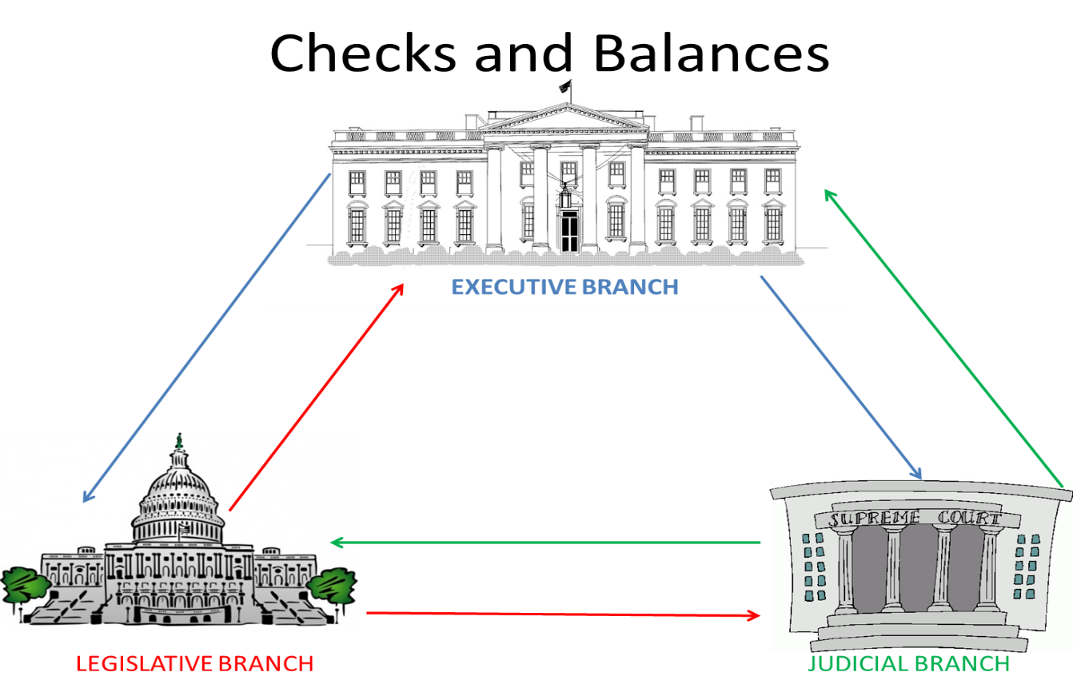
Directions for #31-36: match the letter of the statement with the correct arrow on the diagram.

36.
31.

32.
35.

33.

34.

A. veto legislation; call special session
B. reviews executive orders
C. determines whether laws are constitutional
D. appoints some court officials
E. override veto; confirm appointments; impeach
officials
AB. can propose constitutional changes; impeach officials

