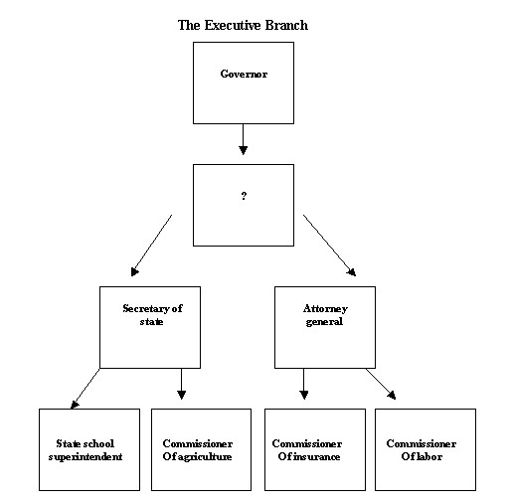
1. Which BEST completes the diagram?
A. The Supreme Court
B. The State Legislature
C. The Lieutenant Governor
D. The Court of Appeals of Georgia

2. According to the system of checks and balances, the executive branch checks the legislative branch
A. by interpreting laws.
B. through impeachment.
C. through the use of the veto.
D. by proposing constitutional changes.

3. In the Georgia government, the governor and lieutenant governor represent the
A. Legislative branch.
B. Executive branch.
C. Judicial branch.
D. Federal branch.

Requirements for Candidates for Governor
Must be 30 Years Old
Must be a U.S. Citizen for 15 Years
?
4.

Which BEST completes the chart?
A. Must be at least a high school graduate.
B. Must have served as a state legislator.
C. Must have served as lieutenant governor prior to the election.
D. Must be a Georgia resident for six years prior to the election.

5. The chief executive of the state is the
A. congressman.
B. governor.
C. mayor.
D. president.

6. A two-term governor can run for reelection only if
A. the current governor is disabled.
B. the other parties have no candidate.
C. the Supreme Court of Georgia allows the present governor to run again.
D. the governor sits out for a minimum of four years before running again.

7. GOVERNOR LIEUTENANT GOVERNOR

- Director of state budget

- Limited to two consecutive terms
- Presides over the state senate
- ?
- Elected at the same time
- Elected for same term
- Must be 30 years old

Which BEST completes the diagram?
A. Must serve on the legislature
B. Does not have to be a resident of Georgia
C. Must run on the same ticket as the governor
D. No limit on the number of terms allowed to serve

8. When elected by Georgia voters, a Governor serves a ________ year term of office.
A. 2
B. 4
C. 6
D. 8

9. In Georgia, the governor and lieutenant governor
A. are elected separately.
B. each serve six-year terms.
C. must be of the same political party.
D. head each house of the General Assembly.

Qualifications of Governor and Lieutenant Governor.
“No person shall be eligible for election of the office of Governor or Lieutenant Governor unless such person shall have been a citizen of the United States 15 years and a legal resident of the state six years immediately preceding the election and shall have attained the age of 30 years by the date of assuming office.”
-Paragraph IV, Section 1, Article V of the Constitution of the State of Georgia

10. What conclusion can you draw from this part of the Georgia Constitution seen above?
A. The Governor and Lieutenant Governor are elected individually.
B. There are no differences in the qualifications of the two offices.
C. The requirements to be Governor are stiffer than to be Lieutenant Governor.
D. The requirements to be Lieutenant Governor are stiffer than to be Governor.

11. Why is the power to make appointments to boards and executive offices important to the governor of Georgia?
- By appointing persons from the same political party, the governor can help one party dominate state government.
- Through appointments, a governor can spread his or her influence far beyond the limited powers of the governor’s office.
- Through appointments to boards and executive offices, a governor can control the actions of all state agencies and boards.
- By appointing political backers and campaign contributors, the governor can repay supporters and raise money for future campaigns.

12. An example of an executive power given to the governor is the power to
- Sign bills
- Appoint heads of agencies
- Send messages to law makers
- Call special sessions of the legislature

13. The lieutenant governor most effectively affects the passage or failure of legislation in the state senate by
- How he or she votes on a bill.
- Assigning senate bills to committee.
- Being able to veto bills in committee.
- Establishing the senate meeting schedules.

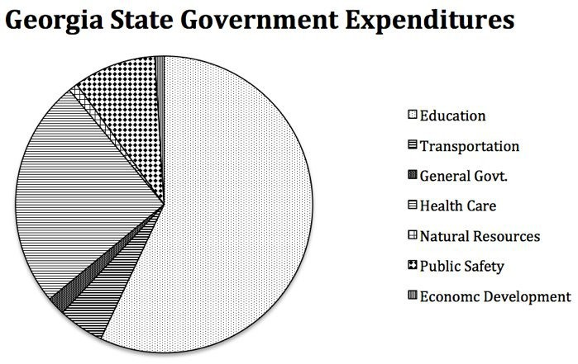
Economic Development

Use the pie chart above to answer questions 14 and 15.

14. What can you conclude about the policy areas in the State of Georgia?
A. Education receives the most money each year.
B. More taxes are needed to improve Economic Development.
C. Transportation is not important to most people in Georgia.
D. Public Safety has seen repeated budget cuts during the decade.

15. Who would be MOST likely to be responsible for making sure the expenditures in the chart above are enforced in state government?
A. The Governor
B. The State Senate
C. The Supreme Court
D. The State House of Representatives

16. Which elected state official controls the administration of state and federal education funds, enforces state education regulations and laws, certifies and licenses teachers and other educators, and approves textbooks for use in Georgia schools?
- Director of Department of Revenue
- State school superintendent
- State treasurer
- Governor

17. Which office maintains the state’s official records, publishes laws passed by the legislature, supervises elections, appoints examining boards, grants corporate charters, and regulates securities, stocks, and bonds?
- Department of Administrative Services
- Department of Community Affairs
- Board of Transportation
- Secretary of State

18. Which executive department is being described by these statements?
- Exercises broad authority over industrial and occupational safety and administration of labor laws.
- Helps individuals attain their work goals and increase self-sufficiency through employment, training, comprehensive rehabilitation, and support services.
- Helps employers meet their business needs through employee recruitment and selection services, workforce information, and technical support.
- The Department of Labor
- The Department of Agriculture
- The Public Service Commission
- The Office of the Secretary of State

19. Which executive department works to ensure “that consumers receive safe, reliable, and reasonably priced telecommunications, transportation, electric and natural gas services from financially viable and technically competent companies?”
- The Department of Labor
- The Department of Agriculture
- The Public Service Commission
- The Office of the Secretary of State

- Commissioner of Insurance
- Commissioner of Agriculture
- Commissioner of Labor
- State School Superintendent
20.

What would be the BEST title of this list of governmental officers?
- “Elected Officials of the Executive Branch”
- “Appointed Officials of the Executive Branch”
- “Officials Controlled by the General Assembly”
- “Officials Appointed by the State Supreme Court”

21.
Attorney General; duties. The Attorney General shall act as the legal advisor of the executive department, shall represent the state in the Supreme Court in all capital felonies and in all civil and criminal cases in any court when required by the Governor, and shall perform such other duties as shall be required by law.
-Paragraph IV, Section III, Article V of the Constitution of the State of Georgia
What conclusion can you draw about the position of Attorney General from the statement above?
- No one is qualified to be the Attorney General.
- The position is held for the life of the individual.
- The position involves being the “main lawyer” for the state.
- Governors usually rely on the Attorney General for election advice.

22. Which office maintains state farmers’ markets, supervises services such as inspections, and expands market opportunities for Georgia?
A. Department of Insurance
B. The Office of the Secretary of State
C. Department of Labor
D. Department of Agriculture

23. Which office regulates insurance carriers and issues insurance licenses?
A. The Office of the Secretary of State
B. Department of Insurance
C. Department of Labor
D. Department of Agriculture

