Emancipation Proclamation
Abraham Lincoln Image Analysis

Directions: Analyze two different images to help you understand differences in public opinion concerning the Emancipation Proclamation. First, review the two images. You may need to enlarge them for best viewing.

Image 1: http://lcweb2.loc.gov/service/pnp/ppmsca/19200/19253v.jpg

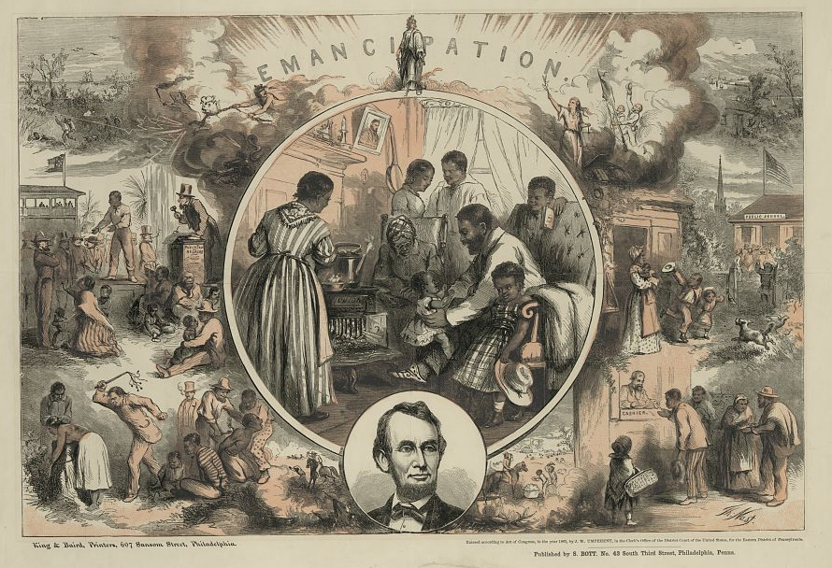

Image 2: https://vahistorical.files.wordpress.com/2012/09/4f-1-lincoln-signing-the-emancipation-proclamation-e6472.jpg

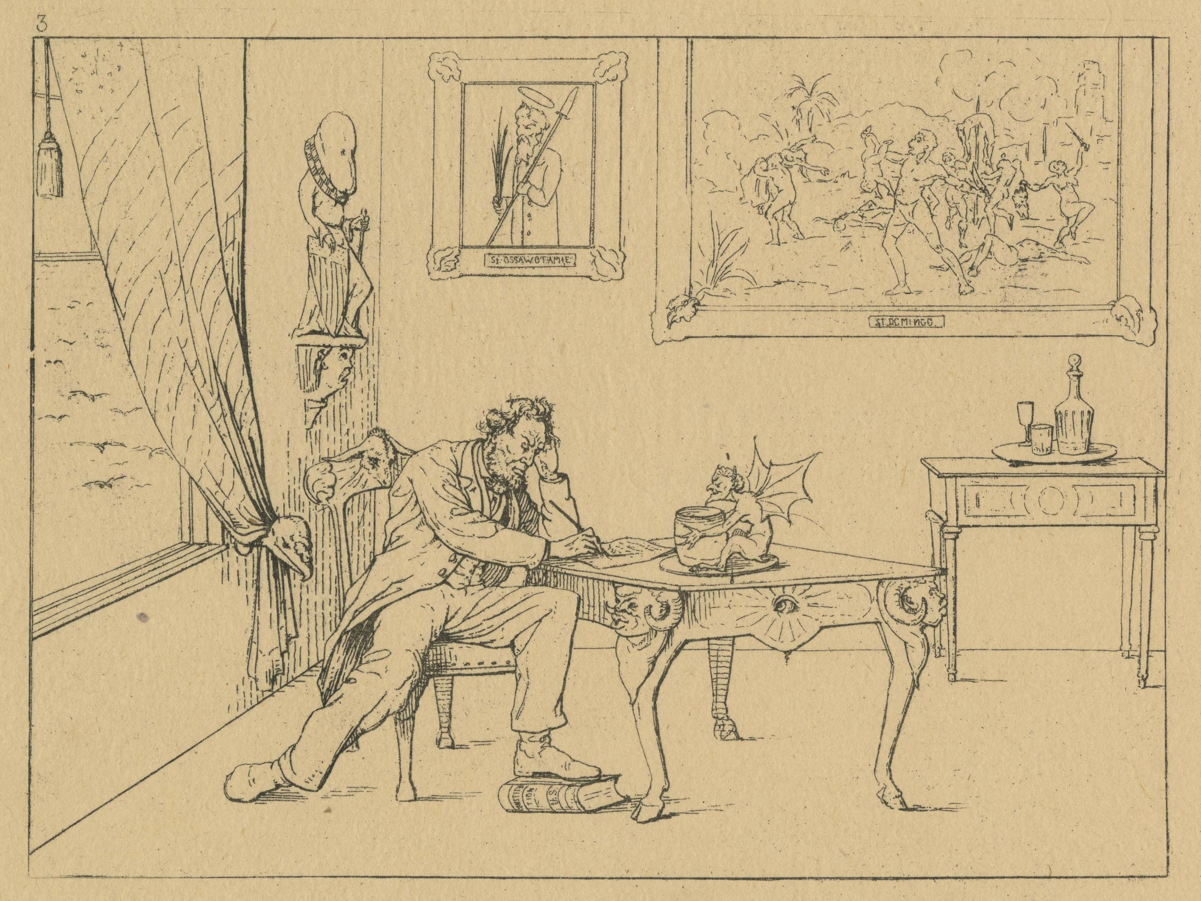

For each image you will answer the following questions:

Observe | Reflect | Question
Describe what you see.  What do you notice first?  What people and objects are shown and how are they arranged?  What is the setting?  What, if any, words do you see?  What other details can you see? | Why do you think this image was made?  What’s happening in the image?  When do you think it was made?  Who do you think was the audience for this image?  What is the illustrator’s bias?  What can you learn from examining this image?  If someone made this today, what would be different and what would be the same? | What do you wonder about?  Who?  What?  When?  Where?  Why?  How?

Answer the following questions:

How did the public view the Emancipation Proclamation differently? Consider the points of view from both the North and South. What can political cartoons tell us about public response to historical events?

