Name: _______________________________________________ Date: ___________________ Period: ______________
The Cotton Gin
In 1793, Eli Whitney invented a simple machine that influenced the history of the United States. He invented a cotton gin that was popular in the South. The South became the cotton producing part of the country because Whitney’s cotton gin was able to successfully pull out the seeds from the cotton bolls.
Eli Whitney was born in Westboro, Massachusetts on December 8, 1765 and died on January 8, 1825. As a young boy he liked to work in his father’s workshop taking things apart, like clocks, and putting them back together again. When he was a young man, he worked on a Georgian plantation tutoring children. He noticed the trouble the slaves were having picking seed from cotton bolls. In his spare time, he put together an instrument that would allow the slaves to clean more cotton in a shorter amount of time.
The cotton gin was a very simple invention. First, the cotton bolls were put into the top of the machine. Next, you turn the handle, which turns the cotton through the wire teeth that combs out the seeds. Then the cotton is pulled out of the wire teeth and out of the cotton gin.
Farmers were able to plant more cotton. Cotton is easy to grow but because it was so difficult to clean, cotton was not a cash crop. Tobacco and indigo were the South’s cash crops. Tobacco is difficult to grow. Tobacco wears out the land and the land must be given a rest once every 7 years. But cotton can grow anywhere, even on land that is drained of its nutrients.
Now that cotton is easier to clean and since it grows easily, cotton became the number one cash crop in the South. The farmers needed more land to grow cotton. They took the land from the Native Americans. The farmers needed more workers. Slaves were the free labor that the farmers needed to harvest the cotton.
This growth of cotton production affected the world. The Northern part of the United States bought more cotton and built more textile mills. England built more textile mills and demanded much more cotton. These were two big markets to which the South sold their cotton. The South was not able to build textile mills because their capital was tied up in their slaves so that they could produce more cotton. The South also did not have the need or the capital to build up a good transportation system, such as canals and railroads.
During the Civil War, the South had many disadvantages over the North. A large portion of their population were uneducated slaves. They had no factories to produce goods and to become self-sufficient when they separated from the North. Because the South had not built up a good transportation system, they were not able to move men and supplies easily across the country, as the North was able to do.
By 1860, cotton was a cash crop. Cotton production in the South had increased. The number of slaves in the United States had increased. The dependency on slaves had increased. Capital had been invested in slaves, not in transportation or factories. All this happened because of a very simple machine, the cotton gin.

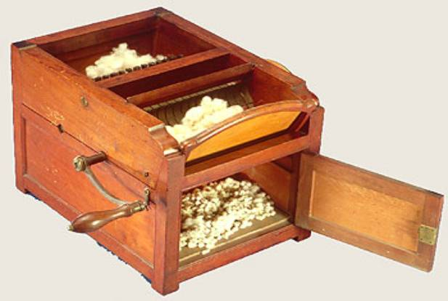
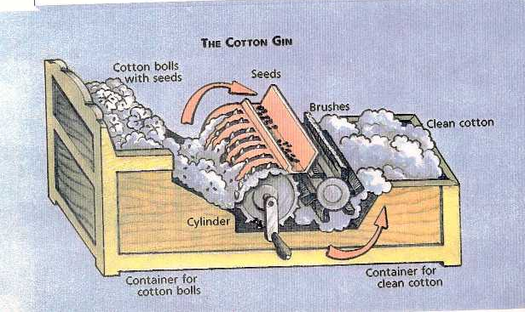
The images below show you how a cotton gin works. Review them, you’ll need them to help you answer questions on the back of this document.
Directions: Use the reading and images on the front side of this paper to complete the following tasks and questions.

Term | Definition
Gin | short for engine
Harvest
Capital
Invest
Patent
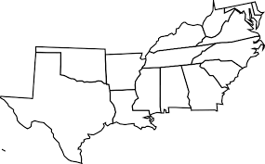
Label the cotton producing states on the map:
- North Carolina
- South Carolina
- Georgia
- Alabama
- Mississippi
- Louisiana
- Arkansas
- Texas
- Tennessee

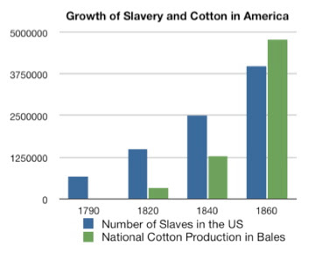
- How does the cotton gin work?

- What products are made from cotton?

- How do you think this cotton gin affects the slaves?

- How do you think this cotton gin helps the plantation owners?

- Do parts of this machine look like other inventions or tools that are known to you? (ex: wire teeth look like a comb)

- What would happen if this would never have been developed? How would it have changed life then and now?

- Could society use it in other ways than intended?

- Explain what life was like in the South without the cotton gin and changes after the cotton gin.

- What can you determine about slavery based on the information provided in the graph? What connection does this have to the invention of the cotton gin?

