Colonial Georgia Assignment

Directions: This project has two parts, make sure you read the directions and follow the checklist and rubric closely. This assignment will be due on Monday September 14th at the beginning of class. Assignments turned in late, will lose 10% a day (see syllabus).

You may use the following resources:
- Textbook: chapter 4; sections 3-4
- CRCT Test Prep Book: pages 22-34

Part 1: Vocabulary
Define the vocabulary words below on your own sheet of paper. When defining, focus on how they are important to Georgia, do not just write a definition.

- Proprietary Colony
- Trustee
- Charter
- Mercantilism
- Cash Crops
- Charity
- Economics
- Defense
- Militia
- Royal Colony

Part 2: Significant Groups and Individuals in Colonial Georgia
- Create a set of trading cards of each of the significant individuals and groups involved in colonial Georgia. I have given you a picture of the person or group, on the back side write the significance. They are listed below:

  - _____ James Oglethorpe
  - _____ Mary Musgrove
  - _____ Tomochichi
  - _____ King George II
  - _____ Salzburgers
  - _____ Highland Scots
  - _____ Malcontents
- Picture and name on the front of the card, information about them and relevance to Colonial Georgia on the back of the card. A template has been provided for you, however, you may draw them on your own.

Checklist | Required Information | Points/Comments
Part 1: Vocabulary | All ten vocabulary words are properly defined and explained in the context of why they are important to Georgia. | 0-30 Points
Part 2: Significant Groups and Individuals in Colonial Georgia | - _____ James Oglethorpe  - _____ Mary Musgrove  - _____ Tomochichi  - _____ King George II  - _____ Salzburgers  - _____ Highland Scots  - _____ Malcontents | 0-70 Points

James Oglethorpe | Mary Musgrove
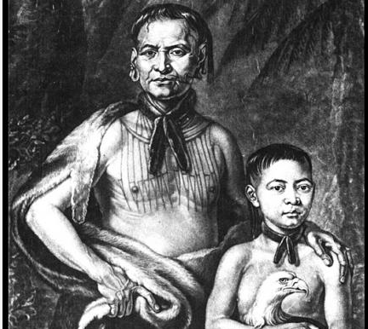  Tomochichi | King George II
Salzburgers  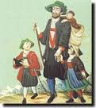 | 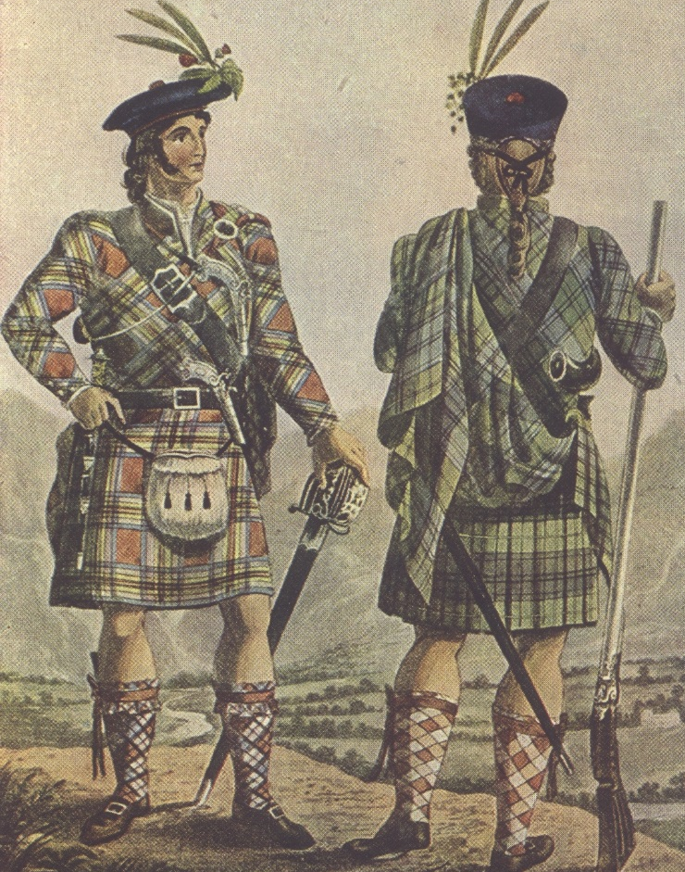  Highland Scots
Malcontents

