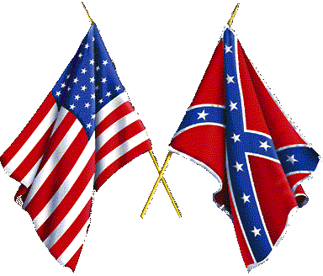
Battle of Chickamauga
Who’s Who?

Background: Abraham Lincoln, Jefferson Davis, Robert E. Lee, Ulysses S. Grant, William T. Sherman, and Thomas “Stonewall” Jackson all played an integral role in the Civil War. As important Union and Confederate leaders, include them in a “Who’s Who” Civil War Project.

Directions: You will create a “Who’s Who” flashcard for each of the following leaders:
- Abraham Lincoln
- Jefferson Davis
- Robert E. Lee
- Ulysses S. Grant
- William T. Sherman
- Thomas “Stonewall” Jackson
On the front of each notecard/flashcard, please include:
- Leader’s full name
- Image of the person
On the back of the notecard/flashcard, please include:
- Name
- Birthdate
- Place of birth
- Date of death
- Title/Job Description
- Union or Confederate leader?
- Contributions, efforts, and significance to the Civil War
- Other interesting facts

