Battle of Antietam
Directions: Create a gravestone AND a eulogy for the thousands of soldiers killed in the Battle of Antietam.
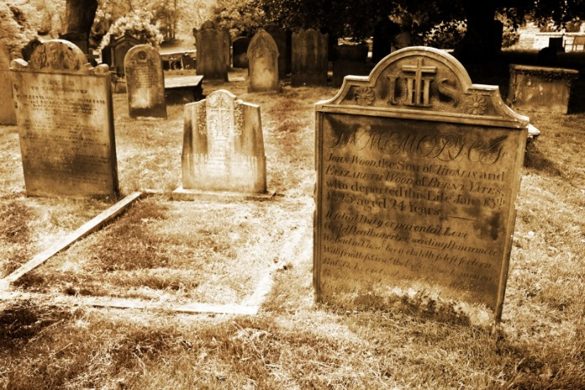

Note: Antietam was the bloodiest one-day battle of the Civil War with more than 26,000 casualties.
Part 1:
Write a eulogy to remember and honor all soldiers who died in the Battle of Antietam. A eulogy is a speech given at a funeral that honors the life of the deceased. Include specific details of the battle (what, when, where, why, how), as well as the significance of the battle and the loss of life for both sides of the war.

Part 2:
Create a gravestone and write an epitaph for the thousands of men killed in battle. An epitaph is an inscription on a gravestone in memory of the person buried there. Your epitaph must include the following information:
- For whom is this gravestone intended?
- Battle name
- Date of death (day of battle)
- Number of casualties
- A verse to commemorate the deceased
- Creative design on the gravestone

