Andersonville Prison’s Captain Henry Wirz
Directions: Read the following passage about Andersonville and Captain Henry Wirz.
Hindered by deteriorating economic conditions, an inadequate transportation system, and the need to concentrate all available resources on its own army, the Confederate government was unable to provide adequate housing, food, clothing, shelter, and medical care for its captives in Andersonville Prison. These conditions, along with a breakdown of the prisoner exchange system, created much suffering and a high mortality rate. More than 45,000 Union soldiers were sent to Andersonville during the 14 months of the prison's existence. Of these, 12,912 died from disease, malnutrition, overcrowding, or exposure. They were buried in shallow trenches, shoulder to shoulder, in a crude cemetery near the prison.
After the war was the arrest and trial of Captain Henry Wirz, the commander of the prison. Wirz was arrested and charged with conspiring to "impair and injure the health and destroy the lives of federal prisoners" and with "murder in violation of the laws of war." At his trial in Washington D.C., many former prisoners testified against him, vividly describing conditions at the prison. The former prisoners (and one who testified but was never actually a prisoner) blamed Wirz as the cause of their suffering. Historical documents, however, attest to the fact that prison officials attempted to acquire supplies for the prisoners but were severely hampered by the need to use supplies for the military and war effort. The question of whether or not Wirz could have done more to make life more bearable for the prisoners is still debated today. Was he simply a convenient scapegoat? Because of public outrage and indignation in the North over conditions at Andersonville, Captain Henry Wirz was found guilty of war crimes and was hanged on November 10, 1865. It has been said that Wirz was the last casualty of Andersonville.
Directions for Writing:
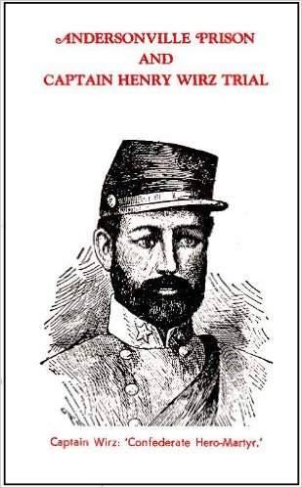
In paragraph format, explain why Captain Henry Wirz should or should not have been executed for his war crimes. Were his actions justified? Use information from the text above, as well as your own research to prove your point of view.

